Mr. Nelson -APHG
Chapters 2 & 9 – POPULATION & DEVELOPMENT

Population:

The first theme of this chapter is factual, and so you’re going to look up on your own (the first few slides of the first PowerPoint, or the first few pages of the textbook). Where are the major population clusters in the world?

The next theme is about how we measure population – meaning what are the measurements or indicators used (*think of all the acronyms)

- CBR
- CDR
- NIR
- Things that effect NIR

(*Remember that CBR – CDR = NIR, not counting net-in migration or immigration)

- IMR
- MMR
- ZPG

The Demographic Transition Model
- 5 stages, listed as 1-5
- No country in stage 1 anymore
- Countries can stay in a stage for a long time, but can’t go back

Stage 1

Stage 2

Stage 3

Stage 4

Stage 5

The visual representation of a country’s stage in the DTM is called a Population Pyramid

***PRACTICE FRQ’S USING POPULATION PYRAMIDS
https://secure-media.collegeboard.org/apc/ap10_frq_human_geo.pdf

How do we read a population pyramid?

What shape does it take for each stage (list the shape next to the stage)

Stage 2
Stage 3
Stage 4
Stage 5

Characteristics of each stage:

Stage 2

Stage 3

Stage 4

Stage 5

Thomas Malthus & Malthusian Theory

Thomas Malthus’ theory stated that:

When did he live (approximately)

Why did he predict this, based on when/where he lived?

Critiques of Malthusian Theory

Neo-Malthusian (*’neo’ means ‘new’) believe what?

Epidemiological Model

What does epidemiology study?

How does this model relate to population patterns

Development:

What is development (definition)

What indicator is used by the UN to measure?

What are the 3 categories of indicators that are used by the UN to track development. List the category first, and then some indicators within that category:

1.)

2.)

3.)

Types of economic activities (jobs! This just means jobs people have!)

Primary

Secondary

Tertiary

Quaternary/Quinary

Rostow’s model of development
*Good video here: https://youtu.be/jgFecxrGceQ

Stage 1

Stage 2

Stage 3

Stage 4

Stage 5

Remember that a country’s development is

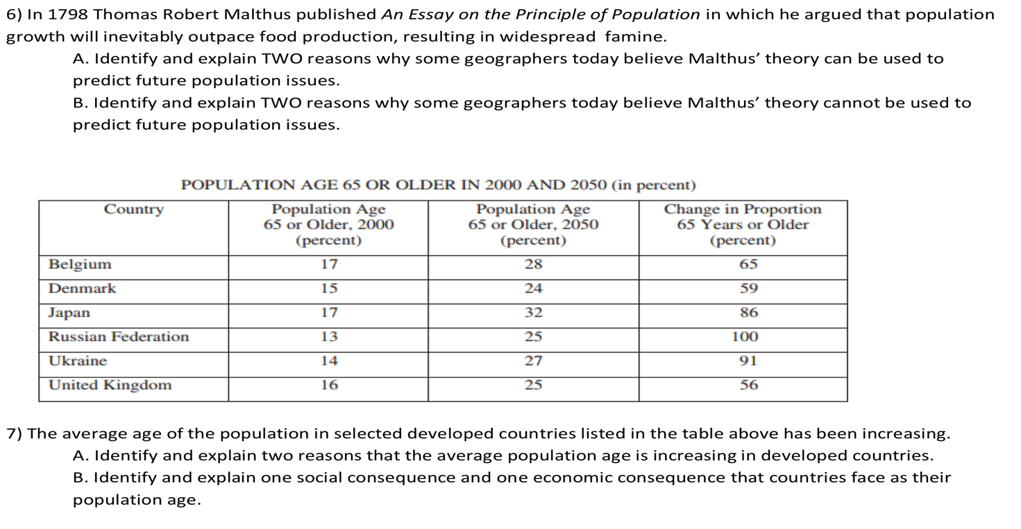
OTHER PRACTICE FRQ’S

