Mr. Nelson – APGH
Assignment – China’s One Child Policy

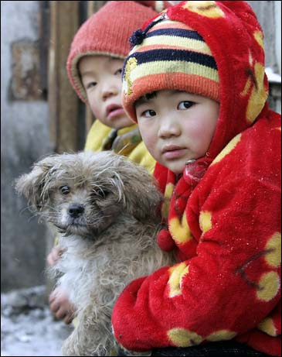

Assignment: We are going to watch the National Geographic episode “China’s Lost Girls”, which details the characteristics and effects of China’s anti-natalist policy from 1979-2015. For this assignment you are to analyze the One Child Policy, addressing all of the following aspects:
- Historical context- how did China come to be in a position where this policy was necessary?
- Details – What is the policy itself? What are the exceptions? Where is it more/less prominent? What are the rewards for adhering to the policy/punishments for violating it?
- Consequences – what are the unintended consequences of this policy? Specifically, how does it impact women? How does it impact men in villages where there are not enough women?
*In addition to the information in the video itself, I want you to use information from at least 2 of the articles below, and use citations.

Sources (at least 2):

China's village of the bachelors: no wives in sight in remote settlement:
http://www.guardian.co.uk/world/2011/sep/02/china-village-of-bachelors

China’s One Child Policy (INFOGRAPHIC):
http://awesome.good.is/transparency/web/1102/land-of-the-rising-son/flat.html

China’s Brutal One Child Policy (Op-Ed, NY Times):
http://www.nytimes.com/2013/05/22/opinion/chinas-brutal-one-child-policy.html

China’s Population - Only and Lonely:
http://www.economist.com/node/18988926?fsrc=scn/fb/wl/ar/onlyandlonely

As China Ages, Birthrate Policy May Prove Difficult to Reverse:
http://www.nytimes.com/2011/04/07/world/asia/07population.html?ref=population

Many in China Can Now Have a Second Child, but Say No
http://www.nytimes.com/2014/02/26/world/asia/many-couples-in-china-will-pass-on-a-new-chance-for-a-second-child.html

