Mr. Nelson – APHG – Homework
nelsonsaphumangeography@gmail.com
www.nelsonsaphumangeography.weebly.com

60 Minutes – Bill & Melinda Gates Foundation: Giving Away a Fortune
(*Link on the website, under Chapter 2)

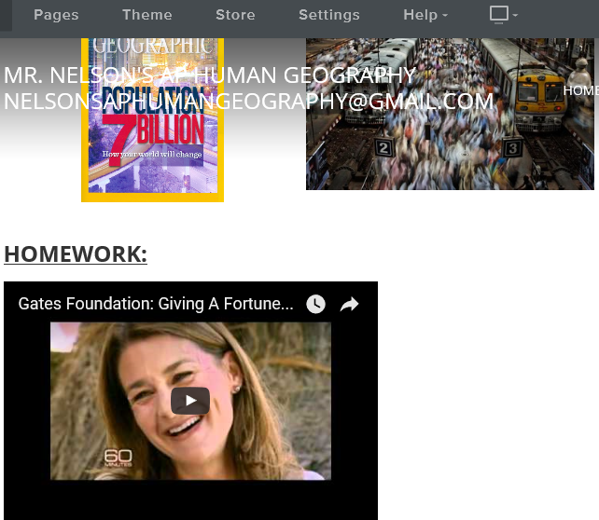

- Summarize the purpose of the Gate Foundation in a single paragraph (in this case it’s okay to be general, but describe some of their central goals as an organization)
- Describe some of the cultural reasons that IMR (infant mortality rate) is so high in the area of India described in the video?
- What are some other indications that part of India is a less developed area (describe what you see, what’s said, etc.)
- Describe what you think the population pyramid of this area of India would look like, and explain all of the characteristics (CBR, CDB, IMR, NIR, MMR) – feel free to draw it.
- What is the reason that polio is so prevalent in parts of India, whereas it’s mostly been eradicated in more developed areas?
- How does the money and techniques of the Gates Foundation improve infant mortality rates?
- Opinion – to what extent do you think that money alone is enough to change the issues that contribute to the high IMR in parts of India (and other parts of the world)? Defend your argument.
Length: Whatever you believe is necessary to get full credit…it’s up to you, but be careful.
Due: Monday, October 16^{th,}, 2017 (by email, no later than 11:59 – earlier is fine)

