Mr. Nelson –APHG

*In the spirit of what we’ve discussed on raising test scores, below are some copied/pasted slides from my PowerPoint (*note, the full PowerPoint can be found on the website, under “AP Exam Review Materials, right at the top). Following that are some sample AP question’s to practice the techniques on - *take good class notes

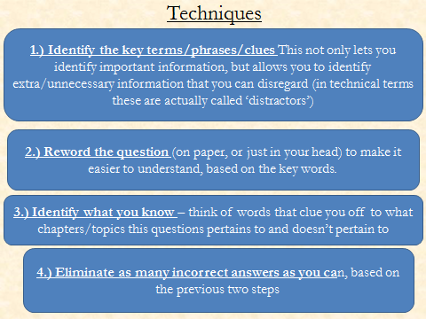

Other notes:
- Sometimes the most important thing in a question can be a single word, like “traditional” or something equally simple. This is good for process of elimination strategies.

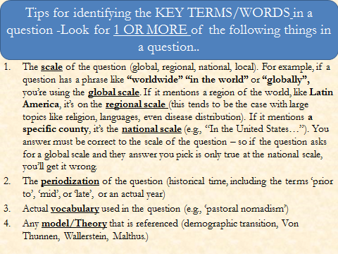
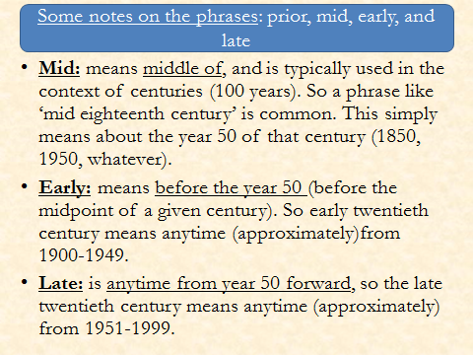

On the next few pages we’ll use examples from last year’s (2016) A.P. Exam. Please notice how many agriculture questions appeared. Let’s the strategies to try to at least get the correct answer narrowed to 2 or 3 choices.

Practice Questions from the 2016 AP EXAM

1.) Subsistence agriculture is most common in which of the following regions?

A.) Great Plains of the United States
B.) Papas of Argentina
C.) Amazon Basin
D.) The Outback of Australia
E.) The Ruhr Valley of Germany

What are the keys words/terms?

What do you know about those key terms – even if it’s a definition – define it and write anything relevant about it below:

Look at the geography they give you, and think of where commercial vs. subsistence farming takes place, based on your reading of the textbook *tip, forget the extra words like ‘Great Plains’, and ‘Outback’ and just look at the countries!
United States
Argentina
Brazil
Australia
Germany

How does this help us eliminate answers? What is the question asking?

Therefore, the answer is choice __________.

2.) Traditional labor-intensive agriculture often involves which of the following?

A.) Field Terracing
B.) Mechanical Plowing
C.) Hybrid Seeds
D.) Use of Pesticides
E.) High Level of debt

What are the keys words/terms?

What do you know about those key terms – what do they tell you about the choices provided?

Based on this, how does this help us eliminate answers, and which answers?

Therefore, the answer is choice __________.

3.) Specialty agriculture and timber production have increased the level of development and gross national income (GNI) of Chile’s economy through which of the following?

A.) Export sales to consumers in the United States, Japan, and other foreign markets
B.) Creation of a trade alliance with Brazil and Argentina
C.) Provision of basic staple foods and building materials to Chilean consumers
D.) An increase in shipping trade from ports along the Strait of Magellan
E.) A focus on plant-based produce that has a long shelf life and does not require preservatives

What are the keys words/terms?

What do you know about those key terms – even if it’s a definition – define it and write anything relevant about it below:

How does this help us eliminate answers? What is the question asking?

Therefore, the answer is choice __________.

4.) A set of economic and political relationships that organizes food production from the development of seed to marketing the products is known as:

A.) Food processing
B.) Mechanized farming
C.) Mixed Crop and Livestock Farming
D.) Agribusiness
E.) Commercial Farming

What are the keys words/terms?

What do you know about those key terms – even if it’s a definition – define it and write anything relevant about it below:

How does this help us eliminate answers? What is the question asking?

Therefore, the answer is choice __________.

5.) Genetic engineering of agricultural crops has primarily increased the productivity of modern farming by:

A.) converting annual plants to perennials, which do not require replanting
B.) increasing the size of fruits and grains
C.) increasing plants’ drought resistance and resistance to pests
D.) cutting the cost of bulk seeds during planting seasons
E.) changing vegetable and fruit colors to suit consumer demands

What are the keys words/terms?

What do you know about those key terms – even if it’s a definition – define it and write anything relevant about it below:

How does this help us eliminate answers? What is the question asking?

Therefore, the answer is choice __________.

6.) Which of the following is the most often cited environmental benefit of the eat-local movement?

A.) Less fossil fuel is used in transporting food to market
B.) Fewer pesticides are used by farmers
C.) Less topsoil is lost to wind and water erosion
D.) There is less demand for chemical fertilizers
E.) It helps local and regional economies

What are the keys words/terms?

What do you know about those key terms – even if it’s a definition – define it and write anything relevant about it below:

How does this help us eliminate answers? What is the question asking?

Therefore, the answer is choice __________.

7.) In which of the following world regions has the Green Revolution had the least impact on agriculture?

A.)East Asia
B.) South Asia
C.) Southeast Asia
D.) Central America
E.) Sub-Saharan Africa

What are the keys words/terms?

What do you know about those key terms – even if it’s a definition – define it and write anything relevant about it below:

How does this help us eliminate answers? What is the question asking?

Therefore, the answer is choice __________.

What are the keys words/terms?

What do you know about those key terms – even if it’s a definition – define it and write anything relevant about it below:

How does this help us eliminate answers? What is the question asking?

Therefore, the answer is choice __________.

What are the keys words/terms?

What do you know about those key terms – even if it’s a definition – define it and write anything relevant about it below:

How does this help us eliminate answers? What is the question asking?

Therefore, the answer is choice __________.
FOR THE NEXT TEXTBOOK QUIZ

Here’s how I would outline the textbook.

I’d divide my notes into Key Issues, but I wouldn’t just use the textbook to make notes to study. Weird as it sounds, I’d gather as much information as possible to help understand the topic, even though the questions will come from the text – this way you’re studying the topic – not just for a particular type of quiz. I’d identify the key terms, vocabulary, concepts, people, or models. So, for this chapter I’d include. Typically these are the bolded terms, but not always:
Textbook:
Key Issue 1: Where is Industry Located (read pages 344-346 *Stop at “Industrial Regions” and don’t worry about memorizing all of them.)
- The Industrial Revolution (know when, where, what it was, and why it began in England)
- Cottage Industry (definition in book is enough)
Key Issue 2: Why are Situation Factors Important (ALL) *note – remember that ‘situation’ in this class refers to where something is, relative to something else (also known as ‘relative location’) – so everything in this section is about where industries have to locate their factories – either near the market place (where people buy) or by the inputs (or raw materials) – that’s the ‘situation’ part of the key issue title.
- Maquiladoras (this is very, very important – know what they are, and everything you can about them. In addition, review the economic supranationalist organization of NAFTA (North American Free Trade Agreement)
- Inputs *not bolded (page 350)
- Bulk-Reducing Industries (sometimes called ‘weight reducing industries’)
- 4 examples of Bulk-Reducing Industries
- Bulk-Gaining (sometimes called ‘weight-gaining’) Industries
- Examples of Bulk Gaining Industries (Fabricated Metals, Beverages, Single-Market Manufacturers, and Perishable Products) * just look over what they are, don’t get nuts with it.
- Read the “Ship, Rail, Truck, or Air?” Section
- Break of Bulk Point (p. 355) with examples of where these are.
Testing Your Knowledge
Time to evaluate if you understand. Below are some sample questions, along with a sample FRQ. You can also look in your review book or on Quizlet.

1) Producers of automobiles select locations primarily because of access to
A) government subsidies.
B) labor.
C) markets.
D) raw materials.
E) fluid capital.
2) The lowest-cost form of transporting goods very long distances is by
A) truck.
B) train.
C) boat.
D) airplane.
E) ox cart.

3) A company which uses more than one mode of transport will often locate near
A) break-of-bulk points.
B) consumers.
C) raw materials.
D) suburbs.
E) abundant energy supply.

4) Beer bottling is an example of a
A) perishable industry.
B) specialized industry.
C) bulk-gaining industry.
D) communications-oriented industry.
E) labor intensive industry.

KEY ISSUES 3 & 4
*A lot of this stuff just isn’t important – I tried to be very specific what the important parts are/aren’t, by page number and topic.
Key Issue 3: Why Are Site Factors Important (p. 356) – remember what ‘site’ is here – the unique, physical characteristics of a place (and in this case it includes a labor force!)
- Labor Intensive Industry (and some examples)
- Textiles
*Just briefly go through the rest of this, but don’t stress over it – some stuff like all the textile sub-headings aren’t very important!
Key Issue 4: Why Are Location Factors Changing (p. 361)
- Right to Work Laws (p. 362) – definition and examples
- Read the subtitle “Outsourcing” on page 365 (know terms “new international division of labor” and “outsourcing”)
- Read the remaining pages (366-368) *including page 367 – it will help you understand on a higher level
- Fordist vs. Post-Fordist production (p. 368)
- Just-in-Time Delivery (p. 368)
PRACTICE THIS FRQ FROM 2004
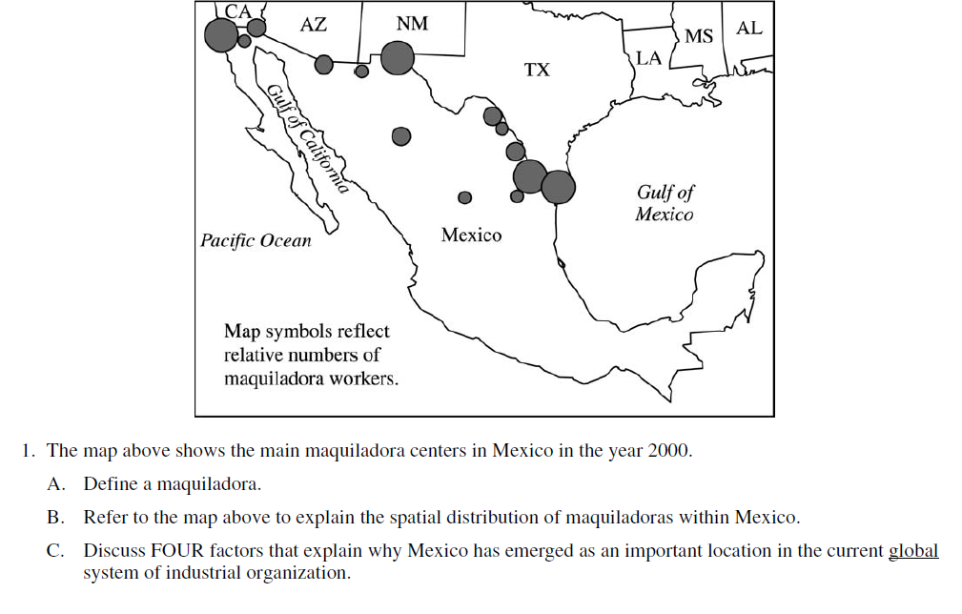
WHAT ELSE DO I NEED TO KNOW?
Industrial Models: look on the class website for handouts I have. You can find them here:

http://nelsonsaphumangeography.weebly.com/ch-8-13.html
- Rostow’s Model of Development
- Hoetelling’s Model
Hotelling Model Video:
https://www.youtube.com/watch?v=jILgxeNBK_8#

- Deindustrialization (not in text – look in PowerPoint and the following)
Deindustrialized America (Photographs):
http://www.huffingtonpost.com/2012/01/12/photographs-of-abandoned-places_n_1197538.html?ncid=edlinkusaolp00000009&ref=fb&src=sp&comm_ref=false#s602434&title=Philadelphia_Pennsylvania_2009

Hotelling Model Video:
https://www.youtube.com/watch?v=jILgxeNBK_8#

How the Garment Industry Came to Bangladesh:
http://www.npr.org/blogs/money/2013/12/05/247360903/nixon-and-kimchee-how-the-garment-industry-came-to-bangladesh

The ‘Economic Belt” of China
http://matthartzell.blogspot.com/2013/09/infogeographic-comparing-urban.html?view=sidebar

A New Capital of Call Centers:
http://www.nytimes.com/2011/11/26/business/philippines-overtakes-india-as-hub-of-call-centers.html?_r=1&pagewanted=all%3Fsrc%3Dtp&smid=fb-share

The 50 largest Ports in the World (Interactive Map):
http://www.smithsonianmag.com/innovation/interactive-50-largest-ports-world-180947915/
What American Sells to the World (Article & Infographic):
http://www.npr.org/blogs/money/2012/03/14/148460268/what-america-sells-to-the-world?sc=fb&cc=fp

Deindustrialized America (Photographs):
http://www.huffingtonpost.com/2012/01/12/photographs-of-abandoned-places_n_1197538.html?ncid=edlinkusaolp00000009&ref=fb&src=sp&comm_ref=false#s602434&title=Philadelphia_Pennsylvania_2009

Mexico's 'maquiladora' labor system keeps workers in poverty
http://www.mcclatchydc.com/2012/06/17/152220/mexicos-maquiladora-labor-system.html

Rolling Tobacco in India:
http://www.washingtonpost.com/world/rolling-tobacco-for-a-living/2012/03/19/gIQAXmcaPS_gallery.html#photo=4

India’s Census: Lots of Cellphones, Too Few Toilets:
http://www.npr.org/2012/04/08/150133880/indias-census-lots-of-cellphones-too-few-toilets

Can Coffee Kick-Start an Economy?
http://www.nytimes.com/2012/04/08/magazine/can-coffee-kick-start-an-economy.html?hp

The Third Industrial Revolution:
http://www.economist.com/node/21552901

Automakers rethink “Just in Time” parts:
http://www.washingtonpost.com/business/industries/automakers-rethink-just-in-time-parts-supplies-as-crises-put-production-at-risk/2012/04/20/gIQAj5yFWT_story.html

